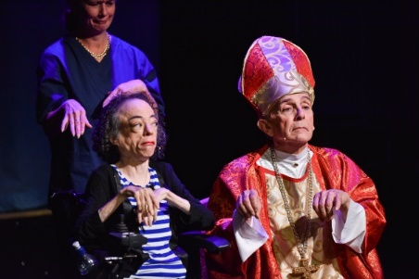
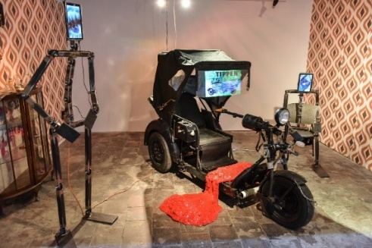
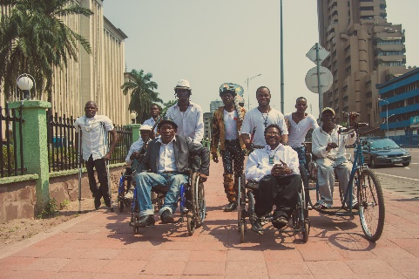
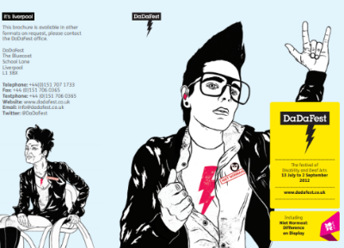
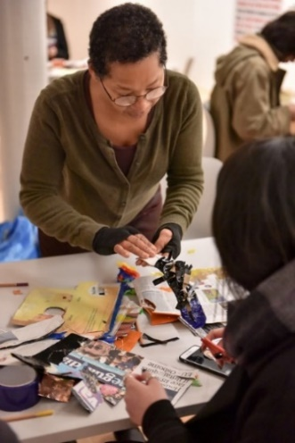
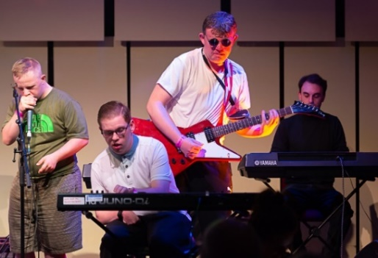
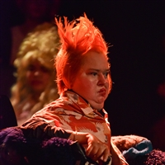
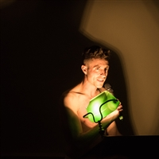
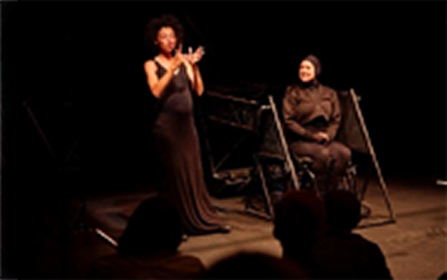
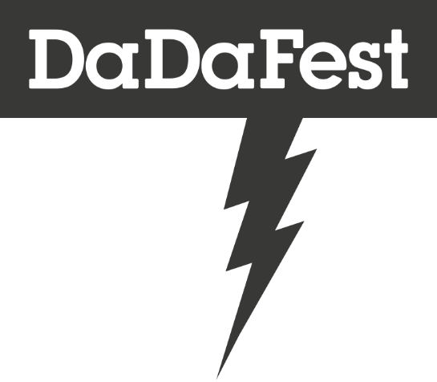
Chief Executive Officer / Artistic Director
Application pack
Deadline for applications: 5.00pm Monday 23 November

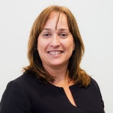
Introduction
Sally Gannon,
Chair of DaDaFest

Thank you for your interest in the post of Chief Executive Officer/Artistic Director of DaDaFest.
We are looking for someone who will bring a new vision, energy and direction to our leading and influential company. They should have a combination of artistic experience and imagination; commercial insight and an entrepreneurial approach to new opportunities.
DaDaFest has an international reach and impact and the CEO/Artistic Director will have the rare opportunity to influence and develop future artists and practitioners, both disabled and non-disabled, create and commission exceptional work and create a new artistic identity for the company.
In light of the ethos of the company, the successful applicant must have direct or personal experience of disability and ideally have experience of working within or for a disabled-led organisation.
We are open to all sorts of discussions about how we cover this role and we are willing to accept both job share and part-time applications. We are committed to flexible ways of working. We will ensure we will manage the logistics of delivering the requirements of the job to ensure that all individual access needs are met.
At this pivotal moment for the company, the Board will consider radical options in terms of the company’s future direction.
We would encourage applications from anyone who can demonstrate relevant artistic experience and a knowledge and understanding of disability arts – this might be theatre directors, creative producers, live artists, designers, and performers. You need to have demonstrated excellence in your discipline and the ability to lead and influence and organisation or groups of practitioners in both formal and informal settings.
We are also aware of the need for the arts to be more inclusive in terms of many different kinds of diversity. We are looking for an artistic leader who will champion inclusivity and ensure representation across ethnicity, class, ability, gender, sexual orientation to strengthen our work, approaches and initiatives.
Within this document you will find background information about the company, job description, person specification and information about how to apply. We are accepting proposals in writing, video / audio format and BSL.

Applications close at 5.00pm on Monday 23 November 2020.

We look forward to hearing from you.

About Us
DaDaFest is a pioneering disability and D/deaf arts organisation based in Liverpool but with international reach and impact. Set up in 1984 (incorporated in 1991) we were one of the first disability-led arts organisations in the UK and an integral part of the campaign for greater equality and access for disabled people.
Our mission is to inspire, develop and celebrate talent and excellence in disability and D/deaf arts. Through stimulating and supporting excellent disability and D/deaf arts from a wide variety of cultural perspectives we help promote and improve the social understanding of disability.
DaDaFest is a disabled-led charity and focused to reflect the lived experience of disability. We believe that disability is a social issue – it is systemic barriers, negative attitudes and exclusion by society (purposely or inadvertently) that are the main contributory factors in “disabling” people.
We use our work to educate, challenge attitudes and help remove the barriers that restrict life choices for disabled people to live independently and equally in society.

Our Funding
We are an Arts Council England National Portfolio Organisation and receive regular funding from Liverpool City Council. Our programme of events and activity is also supported by a wide range of charitable Trusts and Foundations including the Esmée Fairbairn Foundation, Paul Hamlyn Foundation, Children in Need and Youth Music. We have an annual turnover of £515,000.

Organisation and Governance
DaDaFest is a registered charity (Charity Number, 1014390) and a company limited by guarantee (No. 2636606). We are overseen by a non-executive Board of Directors. The Board delegates the day-to-day management of the company to an Executive Team of nine people led by the Artistic Director who is also the CEO.
There are currently several vacancies within the Board and the organisation. The Trustees have taken the decision not to fill these posts until a new CEO/Artistic Director is in place. This will give the appointed person the flexibility to ensure that our executive and charity management structures, systems and processes better reflect the voices of all disabled communities.

Staffing Structure
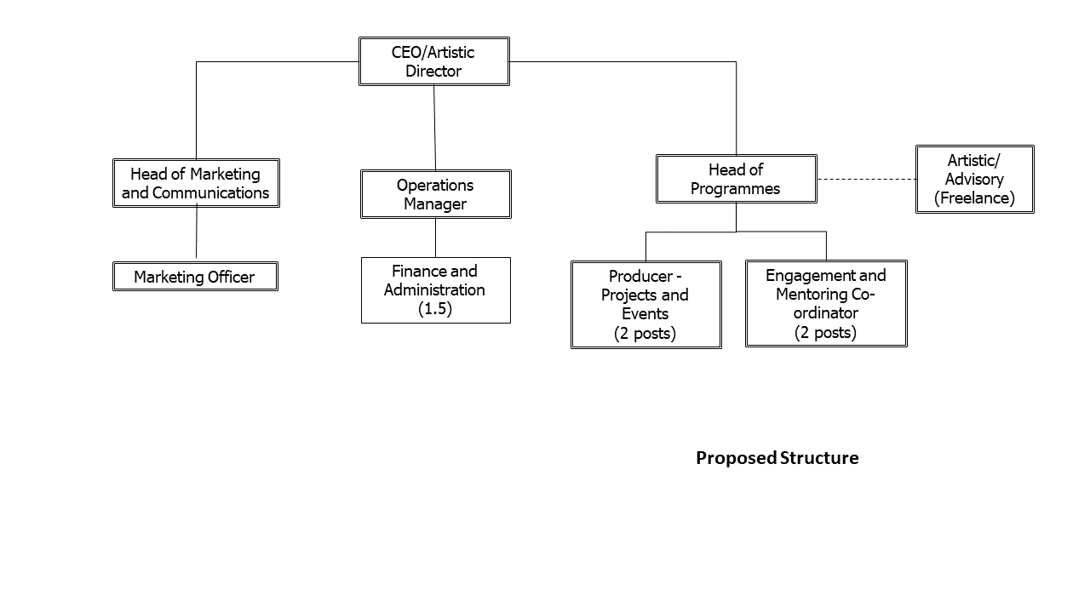
The company is currently part way through a re-structure - seen in the diagram below.
We believe that the company will be stronger with a CEO/Artistic Director and this small team has been designed to ensure that accumulated expertise and knowledge is retained with the company. There is still flexibility within this structure to respond to the new CEO/Artistic Director’s vision.

Our History
Over the last 30 years’ our work has covered varied and combined arts forms including theatre, visual arts, dance and explored the global language of disability culture with the aim of building a more accessible, inclusive and diverse arts and cultural ecosystem.
Our approach includes programming, commissioning and collaborating with international, national and local artists and companies with wide range of both arts and non-arts partners.
We are not a venue-based organisation so have become experts at programming in other people’s homes and non-traditional, but always accessible, spaces. We have presented work in civic halls, churches (from cathedrals to crypts), museums, basements and boats.
We also operate as a critical friend and as an adviser on how best to engage disabled and D/deaf people in the arts as artists, participants and audiences.
We have established long-standing, close collaborations with many venues and organisations locally, regionally and nationally. With some, we have formal agreements which give us the ability to influence a cohort of organisations and artists to include access from the start of, rather than as a later adjunct to, the creative process.
DaDaFest has played a key role in the development of disability and D/deaf arts in the UK and internationally. In 2001 we created DaDaFest International (DDFI) – our festival - to provide a much needed platform for disabled artists. We are now (November 2020) in the process of delivering our 15th successful International Festival.
Over the last 19 years’ the festival has included artists from across Europe, United States, South Africa, Indonesia, Cambodia, Saudi Arabia, India and the Middle East.
Our festivals and events are interspersed with talks and debates addressing the social justice issues raised by the works we present. This programme includes the annual Rushton Social Justice Lecture and the Congress on Disability Culture and Human Rights attended by disability arts practitioners, producers, academics and advocates from UK and overseas.
Our Festival has helped shape the disability arts scene.
Comedian and writer Laurence Clark, whose eight critically-acclaimed solo shows at the Edinburgh Fringe have gained him 29 4-star and three 5-star reviews, had his first ever gig at DDFI.
We launched the career of Liz Carr, now the star of Silent Witness on the BBC.
Our artist in residence for DDFI 2016 - Claire Cunningham, one of the UK’s most acclaimed and internationally renowned disability dance artists, received her first commission as an emerging artist from DaDaFest.
Our success over the years has been recognised; we have won the Merseyside Tourism award for best small event, in 2009 Liz Crow’s Resistance won the Liverpool Echo’s best visual arts event of the year and we were a key player in the 2008 Capital of Culture celebrations.
The International Festival in 2018 demonstrated our wide reaching artistic impact and audience development achievements.
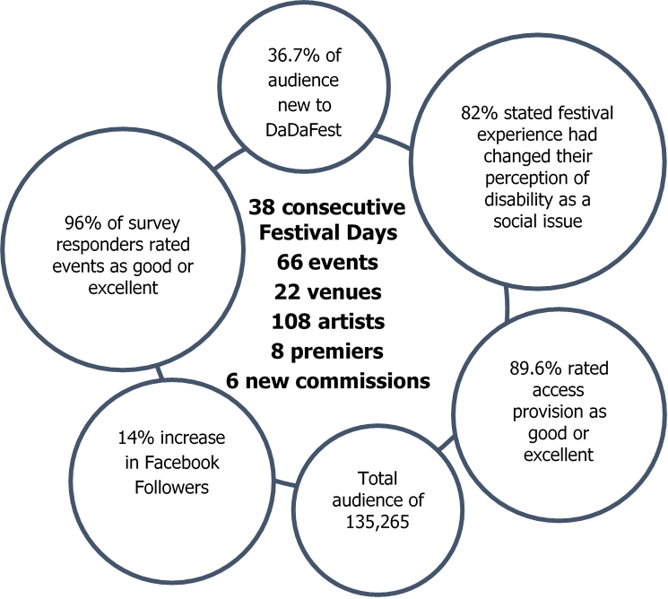

Our 2020 International Festival and the line-up for the planned 2020/21 season builds on our achievements. We have a number of the graduates from our Scratch programme appearing either in the Festival or later in the season.
8 premieres
The festival includes a diverse and intersectional range of artists and you can find out more about our 2020 International Festival artists here: https://www.dadafest.co.uk/artists/

We also deliver an integrated programme of support and skills development for young disabled artists as well as programmes of support and leadership development for young disabled people
Through our Artist Development work we develop the skills of a cohort of disabled young emerging artists through supported commissions. The support includes guidance and advice from DaDaFest and mentoring support and master classes from professional disabled artists, directors and producers.
We also offer one commission per year to an established or emerging professional artist to create a piece of work that has young disabled people at the heart of the creative process.
DaDaFest Scratch is our programme of annual events to highlight the work of those on our Artist Development programme. Our most recent event, a concert in July 2020 by our music Ensemble, premiered a specially commissioned work presented in partnership with Royal Liverpool Philharmonic.
Through our Young Leaders initiative, we support a group of young disabled people to be actively involved in the decision making of the organisation. The group inputs into our delivery, strategic planning and creative programming. The group of about half a dozen young disabled people and two of the graduates from our previous Young Leaders programme sit on the DaDaFest Board of Trustees.
Through DaDaFest Engage, we support development of the generic and transferable skills, confidence and knowledge that young people need to make a success of their future career choices. The programme encompasses a range of activities, commitments and values through which we engage young disabled people with the broader work of the organization, and our partners, in order to widen the range of people able and confident to engage with the arts as participants, employees, volunteers, audiences or artists.
Over 3,500 young people have taken part in creative projects and training including visual arts, performance, creative writing and filmmaking. Our empowerment approach ensures that participants are at the heart of how the programmes are constituted and run.

2020 and Beyond
All of our work over the last 20 years has been innovative, powerful and impactful. However, about 12 months ago we began a process of reflection that will support us in build a vibrant and resilient organisation for the future. We invite the new CEO/Artistic Director help guide us on this journey; to innovate, challenge and imagine the new direction for the company.
Building on past success we want this future direction to:
- Concentrate on longer-term activity designed to bring about sustainable change in external organisations for our artists and participants.
- Produce work that is both reflective of, and challenging to, prevailing values, so we engage more with people traditionally under-represented in the sector – and particularly African, Caribbean and South Asian, East Asian and South East Asian diaspora artists and audiences.
- Further develop the intersectionality of our programmes and collaborations.
- Integrate our young people’s and artistic development work more with the core programme.
- Ensure collaborative working practices are centred in our partnerships to maximise our artistic impact and influence.
The CEO/Artistic Director will rebuild our momentum, re-energise our vision and continue to support, develop and deliver work that is exciting, creative and thought provoking.
We need to work out new methods of delivery that are supported by, and meet the needs of, both our artists and audiences. We need consider what support our artists will need to develop their skills and expertise in a world where the digital and the virtual is likely to play an increasingly important role.
We need an artistic leader to create productions, events, festivals that deliver this vision. How this is realised will be dependent on their approach and interests.

Equality and Inclusion
While we were already in a process of reflection and change, as a social justice organisation and an organisation committed to intersectionality, we also need to reflect on what the systemic racism highlighted by a range of recent events means for us as an organisation.
As an all-white disabled-led disability arts charity we were, and are, acutely aware of the representational challenges we face. Diversity needs to be intersectional and in concentrating specific areas of diversity, we have neglected others.
We are actively working to address this. In the short term, our recently announced artistic commissions and the programme for our festival in November both provide platforms for the voices of the Black D/deaf and disabled artists and support for disabled artists unused to working in the digital world.
We now need to build on this as well as address the medium to long term. We are committed to all staff and Board undertaking unconscious bias assessment and/or training and using the results of this along with advice and guidance from local specialists to inform and re-write a broader range of our policies and procedures.

The Role of the CEO/Artistic Director

About You
We are looking for an inspirational CEO/Artistic Director to lead the future development of this ambitious organisation through what is both an exciting and challenging time.
We need someone with a clear artistic vision, an entrepreneurial spirit, experienced in leadership with a good understanding of disability arts and culture who is not afraid to think creatively and challenge established norms. They will also do this in a way that secures the company’s long-term financial stability and growth.
In light of the ethos of the company to promote the social model of disability, the successful applicant must have direct or personal experience of disability and ideally have experience of working within or for a disabled-led organisation.
We want the Chief Executive/Artistic Director to bring in new thinking, champion boldness, question what contemporary disability arts look like, who makes it and how it is made.
We are seeking someone who will lead DaDaFest’s artistic development, establishing an artistic vision, promoting disability arts and programming our festival and a year-round calendar of events that maintains our organisations profile and nurtures the next generation of disabled artists.
In this role you will also lead DaDaFest’s organisational development, embedding our social justice ethos and vision within a vibrant and sustainable organisation and within our collaborations with external partners to challenge disabled people's marginalisation in all areas of society.
The post holder will report directly to the Board.
The Trustees recognise the barriers D/deaf and disabled people face in society and that, as a result, many disabled people are denied the opportunity to fully develop their employment and leadership potential. To counteract this, the Trustees are committed to providing whatever support, mentoring and training might be required by the incoming CEO/Artistic Director. This support will include the knowledge, relationships and expertise of current Executive Director who will be moving into the role of Operations Manager to further support the CEO/Artistic Director to innovate, re-imagine and realise the company’s new direction.

Job Description - Key Responsibilities
- Shape a bold, pioneering, creative and sustainable vision for DaDaFest that builds on, enhances and innovates its existing reputation
- Commission, curate, and create an annual programme that engages and entertains a diverse audience and encourages them to try a new experience
- Provide inspirational leadership that brings to life the company’s ambitions, achieves excellence and invites innovation and change
- Identify, attract and nurture both established and emerging D/deaf and disabled talent both in the UK and internationally
- Engage and inspire others in their vision such as stakeholders including Trustees, staff, funders artists and present and future audiences
- Regularly see theatres, companies and artists work to search for directors, makers, curators and productions
- Provide strategic creative context for the company’s work with non-professionals including the community and young people
- Develop and maintain collaborative partnerships with other cultural organisations (locally, nationally and internationally) and with other strategic partners
- Lead on DaDaFest’s commitment to inclusion across all protected characteristics (and socio-economic status) and the Creative Case for Diversity, and inspire commitment and action in others
- Ensure the company’s artistic and social justice profile amongst local, regional, national and international practitioners, funders and decision makers is strong and inspirational
- Promote the social model of disability across the sector and make other organisations and individuals aware of the barriers to participation D/deaf and disabled people face and how to avoid them
- Secure funding from Arts Council England and other funders including trusts and foundations, universities, local authorities, businesses and individual givers and manage those relationships
- Act as an active ambassador for the company attending functions, conferences, performances and publicity opportunities
- Create and oversee the implementation of DaDaFest’s Business Plan which articulates the company’s vision, mission statement, aims, objectives, strategies and financial plan
- Lead on recruitment of all key staff and ensure regular appraisals and a training strategy are implemented
- Set and agree the annual budget with the Board and to work with the senior management team to maximise the exploitation of the company’s artistic programme
- Regularly report to and liaise with the Chair and produce reports, attend committees as required and attend all Board meetings
- Lead and manage the Senior Management Team
- Ensure the company confirms to all relevant laws, including charity laws

The list of responsibilities is not exhaustive and the CEO/Artistic Director may be required to undertake additional duties, as operationally required at the discretion of the Board.

Person Specification
Applicants should demonstrate in their application, ideally using personal examples, how they meet the essential criteria in this person specification.
At the same time, we acknowledge that due to barriers and discrimination many disabled people are denied an opportunity to fully develop their employment potential.
We would therefore encourage applications from people who identify as disabled who do not fully meet one or two of the essential requirements but who demonstrate in their application how they would realistically meet those criteria within a defined timeframe. This might be through informal/format mentoring, training, peer networks, etc.
DaDaFest is both an equal opportunities employer and positive about disability. Any candidate who is a disabled or D/deaf person and who demonstrates in the application form that they already meet or, if not, that they have a realisable plan to show how they will meet, all of the essential criteria in the person specification is guaranteed an interview.

Essential Experience
- Personal or direct experience of disability
- Creating, commissioning and/or curating high quality innovative productions and programmes ideally within disability arts
- Management in a relevant sector (e.g. arts, creative industries, public or third sector) preferably within an arts programming or disability arts context
- Forming creative and effective partnerships with a range of stakeholders including funders, artists, other arts organisations
- Talent development and working with or supporting artists to develop their craft and – particularly for D/deaf and disabled artists

Essential Knowledge and Skills
- Demonstrable understanding of the strategic vision, role, purpose, and ethos of DaDaFest (including the social model of disability) and how these are essential in advancing disabled people's emancipation within society
- Up-to-date knowledge of the latest developments in disability culture, the disability movement and the disability arts sector
- Contemporary knowledge of the factors associated with the marginalisation of people because of socio-economic, LGBTQIA+ and African, Caribbean, South East Asian and East Asian, diaspora backgrounds
- Strong knowledge of and contact with individual artists and companies nationally and internationally
- A commitment to widening access to the arts and to developing both audiences and participants in order to challenge marginalisation experienced by disabled people
- Ability to select and develop a coherent programme of high quality work that challenges, appeals to and inspires current and new audiences
- Ability to persuasively articulate the vision of the company to a wide range of audiences including staff, artists, audiences, industry peers, the media and funders
- An ability to listen to, respect and accommodate a range of views in order to broker, negotiate or influence responses to both problems and opportunities

Desirable Experience
- Creating productive relationships with ACE and other funding bodies
- Financial planning, budget setting and management at a senior level
- Leading the business planning process for an entire organisation
- Working with appropriate statutory (e.g. local government, health, housing) agencies to facilitate the development of arts-based projects to address key social issues affecting marginalised communities

Desirable Knowledge and Skills
- Understanding of the reporting requirements of statutory bodies, public funders or trusts and foundations
- Ability to envision new ways of working that ensures continual development of the company’s creative and business models
- Up-to-date knowledge of the public arts funding system and the priorities needed to win and cultivate the support public funders
- Ability to manage, motivate and nurture a diverse staff team
- Awareness of the local and national political landscapes, engaging and lobbying as appropriate
- An understanding of both the broader issues facing the cultural sector and the specific changes and challenges that DaDaFest is likely to face in the coming years

Terms and Conditions

Salary
The salary for this post will be between £40,000 and £45,000 depending on knowledge, skills and experience.

Contract
Permanent

Hours
DaDaFest operates a flexi-time system. All employees are contracted for a standard 35 hours per week. However, the person appointed will be expected to be available as the circumstances demand. Evening and/or weekend work in association with events and performances will be necessary.
We welcome applications from candidates who wish to work in a flexible working pattern (for example around caring responsibilities or access requirements). We are open to the potential for the role to be shared (salary on a pro rata basis).

Location
DaDaFest offices are based at the Bluecoat, School Lane, Liverpool, L1 3BX. In the immediate future all staff are working from home.

Holidays
The leave year runs 1 April to 31 March. The annual holiday entitlement is 25 days, plus all public holidays.

DBS Check
The post-holder must be able to satisfy a Disclosure and Barring Service check for working with children, young people and adults at risk.

Pension
The company provides a contributory pension scheme, details of which are available on request.

Probationary Period
Six months

References
The appointment is subject to the receipt of satisfactory references.

Performance Appraisal
Performance will be appraised at least annually by the Chair of the Board and principal objectives for the following period will be agreed.

Exclusive Service

The CEO/Artistic Director will commit to focus on the role for the first 18 months of their tenure and ideally not undertake any outside work (paid or unpaid) during this time.

If the role is taken in partnership and/or part-time then any additional work in the days not committed to the company is to be expected.

Post 18 months in role any additional work will then be agreed in advance with the Chair. It is understood that freelance work might be undertaken and we make every endeavour to respond positively.

Notice Period
One month during probationary period, rising to six months after confirmation of a permanent appointment.

How to Apply
The recruitment is being led by Sally Gannon (Chair of Trustees).The Regional Theatre Young Director Scheme (RTYDS) is acting as recruitment advisor.
If you would like an informal confidential chat regarding the position before applying, please contact either:
Executive Director, Richard Nutter richardn@dadafest.co.uk
or Sue Emmas, RTYDS at recruitment@rtyds.co.uk
We would actively encourage candidates who wish to explore flexible working options to discuss their thoughts on how an arrangement might work with RTYDS, either prior to applying or during the process.
If you are applying in partnership, please think about how that would work in practice and provide initial thoughts about structure in your application letter.
Deadline: Monday 23 November at 5.00pm

There are a number of ways you can submit an application
Send a CV and covering letter (no more than two pages) addressed to Sally Gannon (Chair of Trustees) including:
- Why you are applying for this role
- How you think you could contribute to the next chapter in DaDaFest’s artistic development
- How your skills and experience match the skills and experience outlined in the Job Description and Person Specification
- Contact details for two referees who have seen your work – whether that’s as a performer, director, producer, designer, live artist etc.
- Completed Equal Opportunities monitoring form which can be downloaded here
Send by email to recruitment@dadafest.co.uk
Please put DaDaFest CEO in the email title.
We are also accepting proposals in video / audio format and BSL – please send a film / audio file no longer than 15 minutes to recruitment@dadafest.co.uk or send a link to the same address for us to download the file.

Interview Process
The process will include two rounds of panel interviews, presentations and an opportunity to meet Board members and staff of the company.
First interviews: Friday 11 December 2020
Second interviews: week commencing 4 January 2021
Please advise us in your submission if you have any problems with availability on the proposed interview dates.

We are working on the basis that all interviews will need to be conducted remotely; this will probably be via Zoom. Please indicate any additional access needs that this approach may raise.
The interview panel will be led by Sally Gannon (Chair) and made up of Trustees. Sue Emmas of RTYDS and a representative of Arts Council, England will be present as observers.

Data Protection
As part of any recruitment process, DaDaFest collects and processes personal data relating to job applicants. DaDaFest is committed to being transparent about how it collects and uses data to meet its data protection obligations. Please read DaDaFest Privacy Notice for further information.
In order to carry out the recruitment process DaDaFest will share the personal data received from you in your application with the RTYDS Executive Team and the shortlisting and interview panel.
Access will be restricted to those involved in the recruitment process. For more information on how RTYDS collects, stores and manages your data please see the RTYDS privacy notice.

